Team Details
Project Title | # 13 Language Learning for Work Proficiency
Team Name | Co-Lingo
GitHub | https://github.com/natashalim-uq/DECO3500_Co-Lingo

Member Information
Name | Student ID | Email | Program of Study
Natasha Lim | 47234855 | natashalim0403@gmail.com  natasha.lim1@student.uq.edu.au | Bachelors of IT (User Experience Design)
Ameera Khaira Tawfiqa | 49847062 | ameeraknazih@gmail.com  a.tawfiqa@student.uq.edu.au | Bachelors of IT (User Experience Design)
Nayla Pramita Dewanti | 48218656 | nayladewanti.edu@gmail.com  s4821865@uq.edu.au | Bachelors of Computer Science
Yajie Han (Isabelle) | 49500947 | yajiehan7@gmail.com  s4950094@uq.edu.au | Bachelors of IT (Software Design)
Trent Ng | 49651072 | trentng2003au@gmail.com | Bachelors of IT (User Experience Design)

Personal Goals
Name | Personal Aims and Goals
Trent Ng | - Build social networks via social media and similar interests  - Develop an original idea and succeed  - Get a product sponsorship  - Develop Backend dev skills  - Develop Frontend dev skills
Natasha Lim | - Meaningfully integrate AI into a final product  - Contribute to the project and work well with the team
Ameera Khaira Tawfiqa | - Design an intuitive UX and aesthetically pleasing UI  - Contribute to teamwork and the project meaningfully  - Create a tool that’ll enable social and mobile connection  - Work on the branding visual guide  - Gain more full-stack development experience
Nayla Pramita Dewanti | - Creating a unique branding visual guide for our product  - Develop technical skills in app/website development  - Identify and solve issues that may rise during production
Yajie Han (Isabelle) | - Contribute meaningfully to the design and development of the project  - Develop my technical and design skil  - Gain more experience on projects

Team Strengths
Name | Personal Strengths
Trent Ng | - Front-End Skills: HTML, CSS, JAVASCRIPT, Native react  - Audio editing / recording skills  - HCI Design principles  - Multi-Media skills: Photoshop, Canva, Sony Vegas, After effects  - Figma
Natasha Lim | - Creative experience: Adobe Creative Suite, Figma, Canva  - Programming languages: HTML, CSS, JS, React, Python, SQL, PHP
Ameera Khaira Tawfiqa | - Both technical and creative experience  - Programming languages:  - HTML, CSS, JS, React, Python, Go, Java, C, Rust, PSQL  - Creative experience:  - Figma, Canva, Clip Studio Paint, Adobe Creative Suite, Cap Cut  - Public speaking, pitching and presenting  - Storytelling  - Creating hackathon-style / business pitch deck
Nayla Pramita Dewanti | - Creative experience with Adobe Creative Suite, Figma and Canva.  - Programming languages: HTML, CSS, JS, REACT, and Python.
Yajie Han (Isabelle) | - Programming languages: HTML, JAVA, Python, REACT, and basic SQL  - Creative experience with Figma and Canva.  - HCI design principles.

Communication Plan
- Main channel: Instagram
- Backup channel: Email
- Expected response time: Within the day or 1 day max.
- Meeting schedule/format: On Zoom? Or instagram
- How decisions get made: Talk about work and tasks and delegate. If any issues arise, we can just talk about it. Everyone will have an opportunity to share their opinions. If the situation cannot be resolved, it will be put to a vote. If a vote is tied, the team will seek external opinions.
- How you’ll use GitHub to manage work: Through respectful and progressive work ethics

Conflict Resolution Plan
- Define what “conflict” looks like for your team (e.g. missed responses, weak output, late delivery): Miscommunication, delegated task not meeting requirements/standards
- How issues get raised: If a task is not completed by the deadline, the team can bring it up and talk about it.
- What happens if it can't be resolved internally (without going straight to staff): Group vote on what should be done moving forward. The person who did not complete the task will have to finish it as soon as possible. If the person still did not finish the task/task is not up to standards, then we can seek staff opinions.

Signatures
Signature | Date
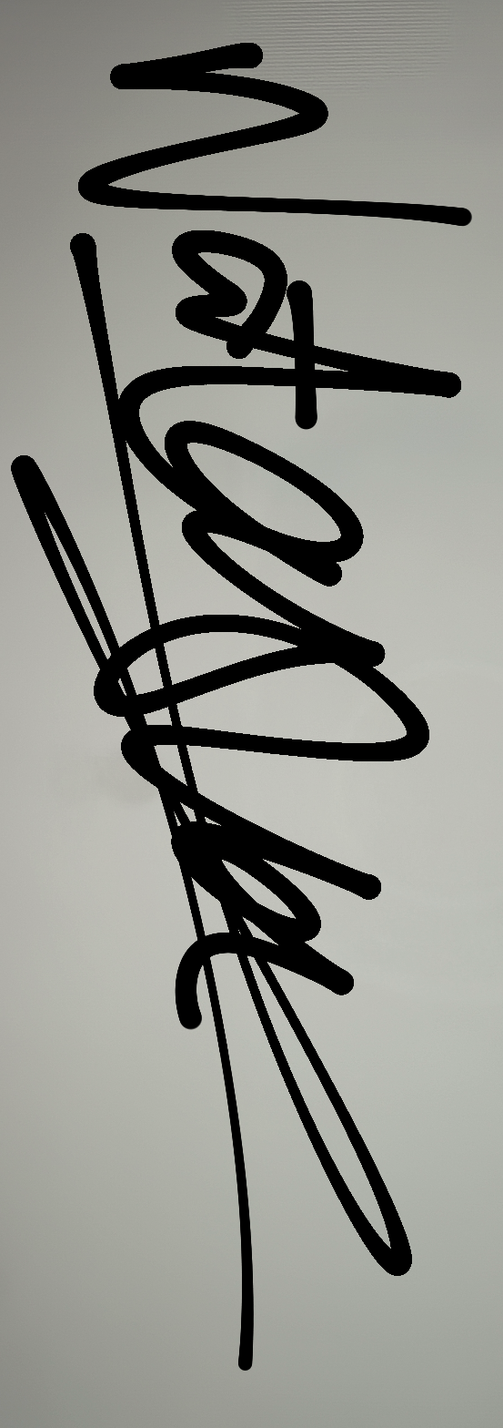  Natasha Lim | 11/08/2026
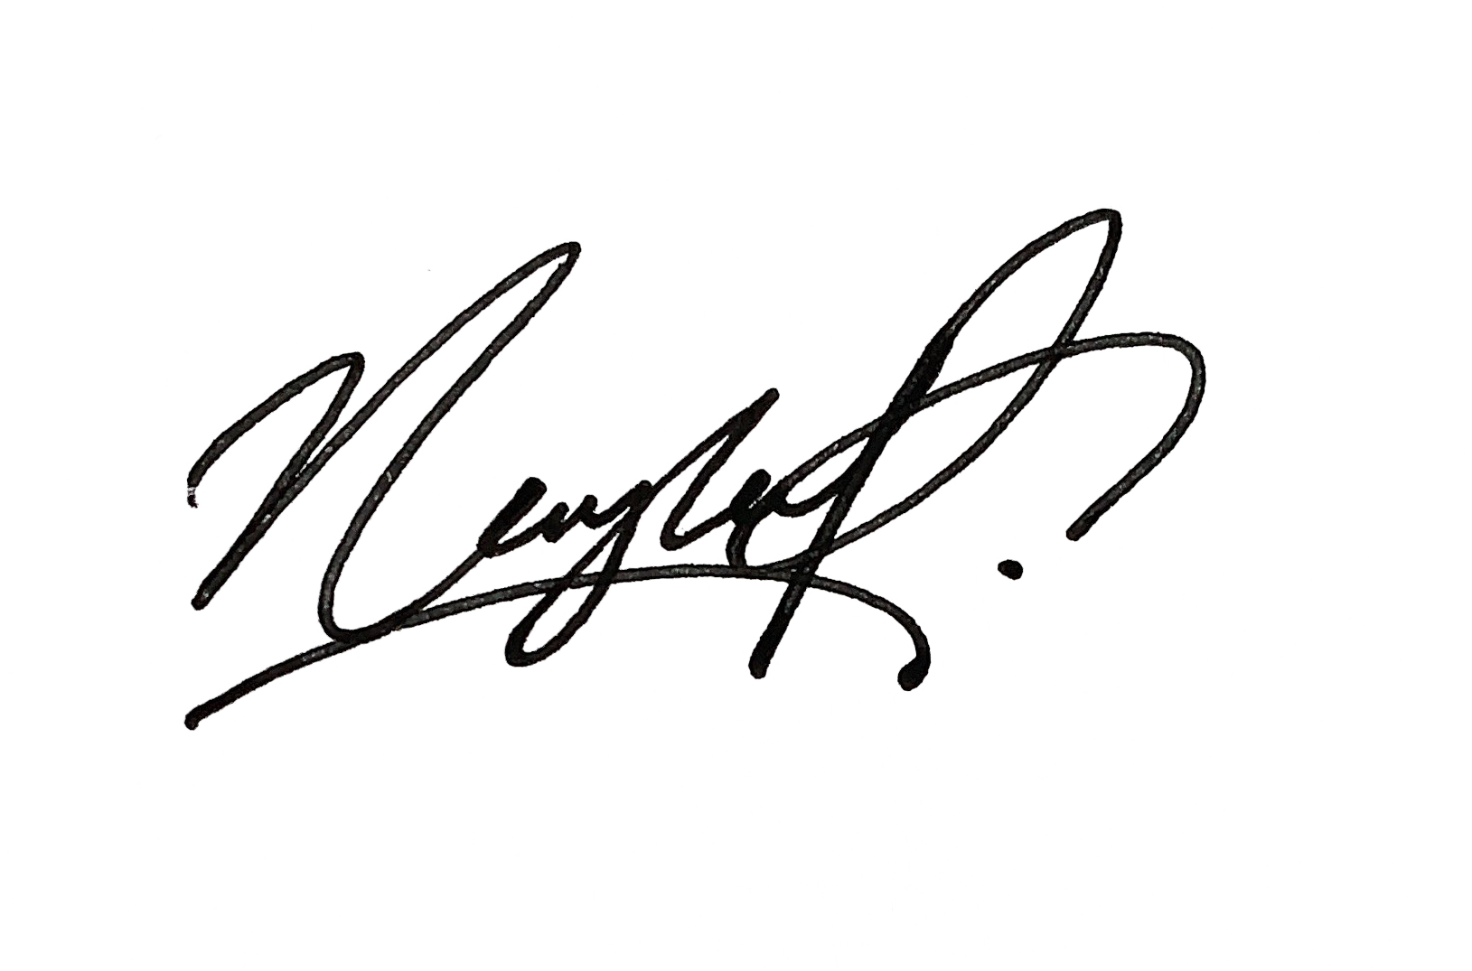  Nayla Dewanti | 11/08/2026
……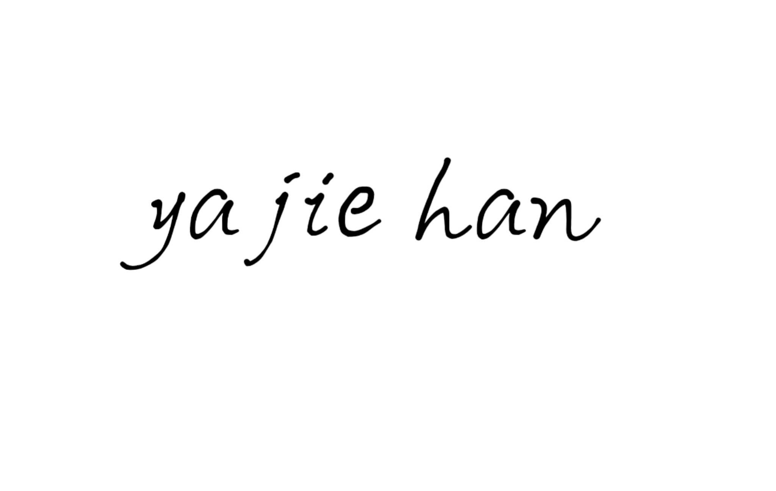  Yajie | 11/08/2026
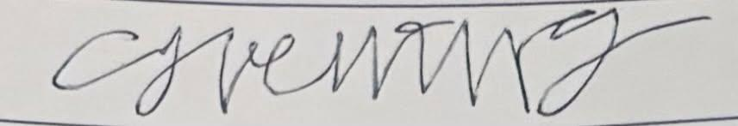  Trent Ng | 11/8/2026
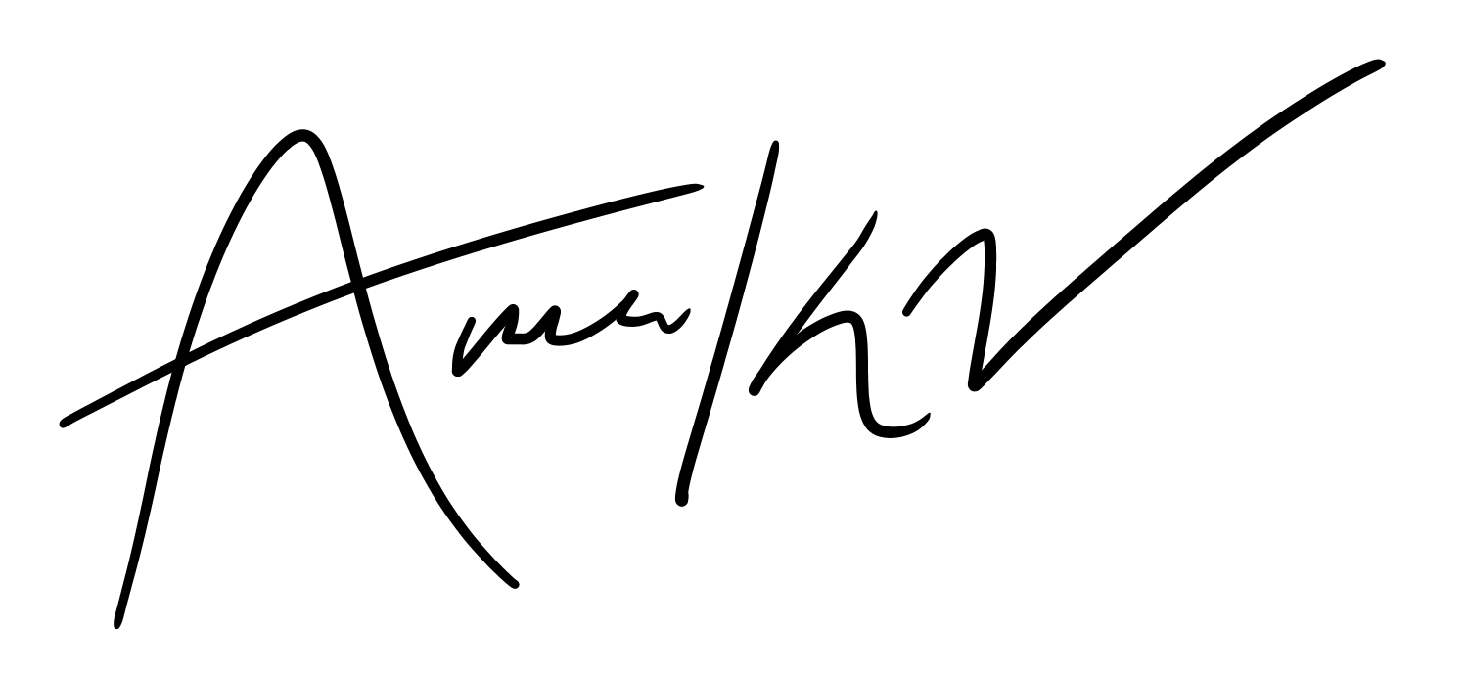  Ameera | 11/8/2026

